【英語】避難所の感染症は予防が大切

Prevention measures are key in preventing infectious diseases at the evacuation center!

The three most important measures are washing your hands, wearing a mask, and upholding coughing etiquette.

●　Let’s wash our hands before eating meals and after using the toilet!

|  |  |  |  |  |  |
| --- | --- | --- | --- | --- | --- |
|  |  |  |  |  |  |
| First, wash your hands with running water | Second, put soap on your hands. | Third, wash between your nails and finger tips. | Fourth, wash your thumbs and palms | Fifth, wash your wrists as well. | Lastly, wipe your hand with a handkerchief, towel or paper towel. |

●When coughing or sneezing, please cover your mouth and nose with a tissue and face away from other people around you.

●Please immediately discard used tissues into a garbage can.

●Please eat the meals distributed at the evacuation center right away. Do not save them for later.

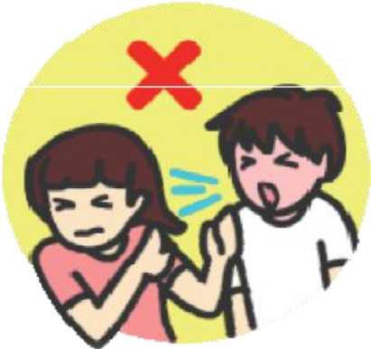●Please drink the evacuation center water after confirming with a staff member that it is potable.

●Please discard diapers at designated areas.

●Please do not dispose of vomit with your bare hands.

What should you do when you have suspicious symptoms?

●Please wear a mask when you have a cough. Even if it is a light cough!

●If you have the following symptoms below, please quickly consult with a doctor or a hygienist, and seek diagnosis at a medical institution.

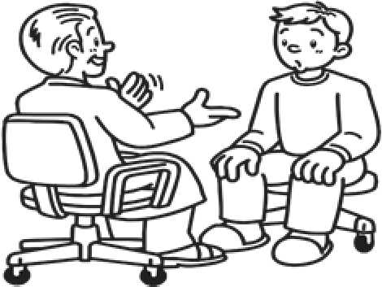A bit feverish, having a cough, yellow phlegm, vomit, diarrhea, difficulty breathing, breathing heavily, looking ill, and feeling drained of all energy, etc.